The Wall Street Journal, October 17, 2019

‘Stolen’ Review: Kidnapped Into Slavery

The story of ﬁve free black boys who, in 1825, were abducted in Philadelphia and smuggled south on the “Reverse Underground Railroad.”
By
David S. Reynolds
Oct. 16, 2019 6:14 pm ET

STOLEN
By Richard Bell
Simon & Schuster, 318 pages, $27
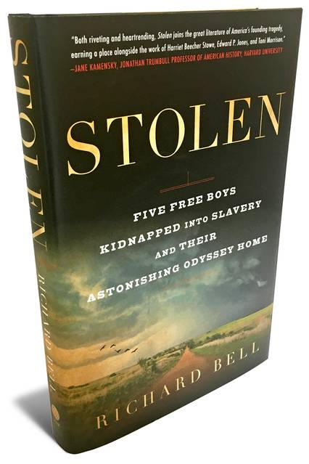

Free black people living in the North in the decades before the Civil War faced severe challenges. They were Jim Crowed in trains, restaurants and hotels. Most had menial jobs, and in the majority of states they could not vote. But the grimmest threat of all was to be kidnapped, taken south and sold into slavery. The story of Solomon Northup is well known, thanks to the film “12 Years a Slave.” In 1841 Northup, a free black man living in New York state who supported his family as a carpenter and fiddler, was tricked by two confidence men who clapped him into a slave pen in Washington, D.C. Sold into slavery, Northup was held on Louisiana plantations for a dozen years until he was able to send a letter home to Saratoga, which led to his release from his illegal enslavement.
Northup’s kidnapping was not an isolated case. The abduction and sale of Northern blacks was appallingly common. Studies such as Carol Wilson’s 1994 “Freedom at Risk: The Kidnapping of Free Blacks in America, 1780-1865” show that hundreds, perhaps thousands, of free blacks were seized in the North and sold in the South by profit-seekers who often passed themselves off as federal agents returning fugitive slaves who had escaped from their masters.
In his book “Stolen,” Richard Bell, who teaches history at the University of Maryland, gives us an up-close look at the kidnapping and illicit enslavement of Northern blacks on what he calls the Reverse Underground Railroad. Mr. Bell’s gripping, often chilling narrative traces the dramatic story of five African-American boys in Philadelphia who, in August 1825, were lured onto a ship, chained in its hold and taken to Maryland and Delaware and then on to Norfolk, Va. From there, the boys, along with two kidnapped black women, were led on a 1,100-mile trek southwest through four slave states by a husband-and-wife team, Ebenezer and Sally Johnson, who planned to sell them to Southerners.
The four-month journey was grueling. The three oldest boys and the two women walked, while the two youngest boys traveled in a horse-drawn wagon. The roads were terrible, and the summer weather alternated between scorching heat and drenching rain. In mid-October the Johnsons sold one boy, Cornelius Sinclair, to an Alabama tinner for $300. Ebenezer Johnson was always ready to punish recalcitrant captives. When he caught 15-year-old Sam Scomp trying to run off, Ebenezer flogged him mercilessly with a lash and a metal paddle. Sam survived, but another teenager, Joe Johnson, did not. Ebenezer smashed his head against an iron wagon wheel. Within two hours, Joe was dead.
The murder put the Johnsons in a quandary. The Southerners they catered to, wary of being suckered, were on the lookout for kidnappers who made illegal sales. The Johnsons, realizing they had to jettison their captives to avoid exposure as criminals, likely sold one woman and then transferred control of the other woman, along with the three remaining boys, to a Mississippi planter, John Hamilton. The boys soon convinced Hamilton that they were from the North and had been kidnapped. Hamilton went to a local lawyer, who contacted Philadelphia mayor Joseph Watson.
The mayor confirmed the boys’ story by tracking down their relatives. He then arranged through two Louisiana merchants, Benjamin Morgan and Joseph Bennet Eves, to have the boys picked up by boat in Natchez, Miss., and taken downriver to New Orleans, where in May 1826 they boarded a ship that took them back home. The woman whom Hamilton had taken stayed in the South temporarily but soon regained her freedom, as did the recently enslaved Cornelius.
This abduction case, Mr. Bell shows, became a cause célèbre when criminals involved in the kidnapping were put on trial. Testimony provided a graphic record of virtually every phase of the crime, from the initial luring of the boys with promises of employment through their forced journey across the South to the suffering they endured along the way. The publicity surrounding the trial spurred the formation of antikidnapping societies and liberty laws in Pennsylvania and elsewhere. But child-snatching and the kidnapping of black adults continued. In 1831 abolitionist Benjamin Lundy moaned, “How many poor wretches are abducted in this way, God only knows!” A Richmond resident declared in 1850, “Kidnapping is the order of the day.”
The furor over abductions increased tensions between North and South. In 1842 the Supreme Court strengthened the federal government’s authority over the return of runaway slaves—one of several pro-slavery rulings or laws that came to include the Fugitive Slave Act of 1850, which stiffened penalties on those who assisted runaways; the Kansas-Nebraska Act of 1854, which opened up the western territories to slavery; and the Dred Scott decision of 1857, which denied citizenship to black people. These changes in the law, as well as the pro-slavery administrations of Franklin Pierce and James Buchanan, made the 1850s a dangerous time for free blacks, who confronted what Mr. Bell calls “a terrifying wave of new abductions.” The actions of slavery’s defenders became increasingly violent, and bloody warfare erupted in Kansas Territory and at Harpers Ferry, Va., which the abolitionist John Brown invaded in 1859 in a bold, doomed effort to topple slavery.
The plight of free blacks in the North remained a pressing topic. With growing frequency, slavery itself was referred to as “kidnapping” or “man-stealing.” The Republican Party’s rising star, Abraham Lincoln, reluctantly accepted the Fugitive Slave Law because of a clause in the Constitution about returning fugitives from labor, but he protested, most famously in his First Inaugural, against the widespread violation of due process that resulted in free African-Americans in the North being seized and taken south to be sold there.
In “Stolen” Richard Bell brings to life amoral con men, heartless slave dealers and suffering victims. He vividly re-creates the squalid social environments of interstate human trafficking. His superbly researched and engaging book exposes previously hidden horrors of American slavery.
Mr. Reynolds, a professor at the Graduate Center of the City University of New York, is the author of “Walt Whitman’s America,” “John Brown, Abolitionist” and other books.

