In the Shadow of Slavery
David S. Reynolds
Merging memoir, travelogue, and history, Clint Smith evokes the horrors of slavery.
February 24, 2022 issue
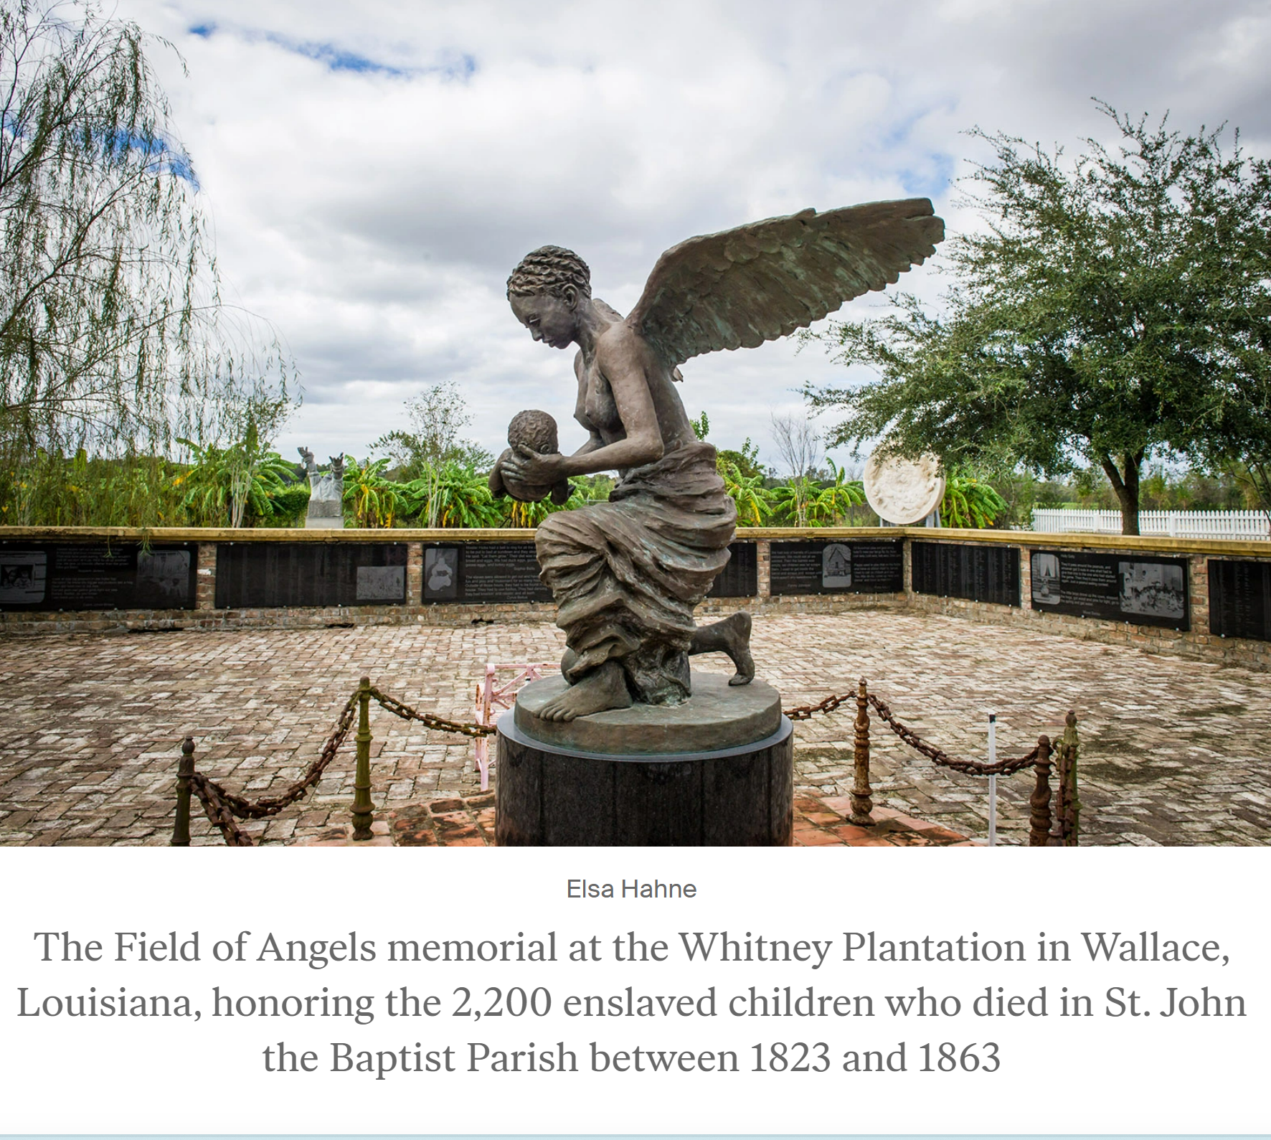

How the Word Is Passed: A Reckoning with the History of Slavery Across America
by Clint Smith
Little, Brown, 336 pp., $29.00
In How the Word Is Passed, Clint Smith evokes the horrors of slavery, from the discovery of the New World through the Civil War, and the widespread victimization of blacks since then. It’s an unsettling story that Smith, an Atlantic staff writer and a poet, tackles unconventionally. He gives us history in poignant journalistic vignettes as he recounts visits he made to southern plantations, a maximum-security prison, a Confederate cemetery, a Juneteenth celebration, slavery sites in New York City, and an African point of departure for enslaved people transported west on the Middle Passage. Merging memoir, travelogue, and history, Smith fashions an affecting, often lyrical narrative of witness marred occasionally by overstatement. His originality lies in his lively inclusion of a variety of voices on race and his graphic depictions of often neglected historic places.
In his prologue, Smith establishes a personal tone as he recalls growing up in New Orleans without knowing that it had once been the largest slave market in America. He argues that the removal in 2017 of four controversial memorials, including ones to Robert E. Lee and Jefferson Davis, was inadequate atonement for past injustices in a city where there are still more than a hundred statues, streets, parks, and schools honoring Confederate figures.
During his visits to slavery-related sites and events, which took place between October 2017 and February 2020, Smith taped conversations with tour guides, attendees, and others. His tour of the reconstructed slave quarters at Thomas Jefferson’s estate, Monticello, leads him to dwell on how the Virginian’s famous words “all men are created equal” were severely compromised by the fact of his holding people in bondage. Smith points to “the contradictions of Jefferson’s legacy” and “the people he allowed to be threatened, manipulated, flogged, assaulted, deceived, and terrorized.”
Also, he notes, Jefferson was “not singular in his moral inconsistencies; rather he was one of the founding fathers who fought for their own freedom while keeping their boots on the necks of hundreds of others.” Describing the nearby Montpelier plantation, where James Madison kept hundreds of enslaved people, Smith asserts:
Both of the men inscribed words that promoted equality and freedom in the founding documents of the United States while owning other human beings. Both men built a nation while making possible the plunder of millions of people.
This point has long been made, with special intensity in recent times. The Founders are now commonly understood to have been idealistic but flawed people who initiated a halting, often backsliding, but ongoing national journey toward freedom and equality. Smith’s passionate doubling down on this theme is understandable now that rabid right-wing jingoism is growing louder. But he goes too far when he jettisons Jefferson’s principal document, on whose text all American struggles for justice were formed. Smith asks, “What is the Declaration of Independence but a parchment of half-truths and contradictions?” Actually, the Declaration’s doctrine of equality is a shining standard that remains humanity’s highest goal. The faults of Jefferson and Madison do not negate the merit of the principles that they championed.
Fortunately, Smith devotes most of How the Word Is Passed not to questioning these principles but to exposing the ways in which many Americans throughout history have failed to live up to them. In this he succeeds. One of his interlocuters at Monticello says that Jefferson contributed “great things,” but that “to fully understand him, you have to grapple with slavery.” Smith discusses passages in Jefferson’s Notes on the State of Virginia that present blacks as inferior. He also reports taking the Slavery at Monticello tour, featuring Mulberry Row, where some of Jefferson’s slaves lived. When he enters a slave cabin, he is appalled by how little shelter it offers. The cabin, which is only about a quarter of the size of the entrance hall of Jefferson’s 11,000-square-foot mansion, is open to the elements, with cracked wooden walls and a porous ceiling.
Smith interweaves first-person renderings of such scenes with historical facts. He learns that of the nearly 700,000 interstate sales of enslaved people in America in the pre–Civil War decades, a quarter of them destroyed a first marriage and half broke up a nuclear family; many involved the separation of children from parents. (Jumping briefly to recent times, Smith reminds us that by 2018, Donald Trump’s administration had separated roughly three thousand children from their parents at the US-Mexico border.) Although Jefferson generally tried to keep enslaved families at Monticello together, he sold children as young as thirteen, and while he said that physical punishment must happen only “in extremities,” he once wrote that he had a recaptured fugitive slave “severely flogged in the presence of his old companions.”
Then there is the issue of Jefferson’s long-term relationship with an enslaved woman. Shortly before his wife, Martha, died in 1782, Jefferson promised her that he would never remarry. He kept the promise, but in the late 1780s he began a decades-long relationship with Martha’s teenaged half sister Sally Hemings, the quarter-black daughter of Martha’s father, John Wayles, and the enslaved Elizabeth Hemings. They apparently had at least six children, four of whom survived to adulthood. Calling Sally “a shadow without a body,” Smith adeptly reviews the historical and DNA evidence that has led most recent historians to confirm the relationship.
Smith continues the discussion of sexuality and slavery in recounting his visit to the Whitney Plantation, a former sugarcane farm an hour west of New Orleans that was turned into a slavery museum by the millionaire John Cummings, who reveals that he has read around 1,100 oral histories by enslaved people and has yet to find one “where the woman was not raped or the man was not almost beaten to death or branded or his finger cut off or his ear cut off for trying to run away.” Because human chattel was valuable property, more black babies meant more money for slaveholders, who paired fertile women with enslaved men. One woman, her daughter attested, had fifteen children, and “none of them had the same pa. Every time she was sold she would get another man.” Smith observes that slaveholders had behind them “the power of the state, the power of patriarchy, the power of a society. These acts were not only permissible but legally encouraged. There were laws stating that almost any crime committed by a white person against a Black person was in fact not a crime at all.”
Forced breeding created a surfeit of enslaved children. By 1860, 57 percent of American’s four million enslaved people were under the age of twenty. A disproportionate number of children held in bondage died young. Smith visits an area of the Whitney Plantation called the Field of Angels, built to honor the 2,200 enslaved children who died in St. John the Baptist Parish between 1823 and 1863. There he is struck by a statue of an angel down on one knee, her eyes fixed on the corpse of a young child cradled in her arms. The statue, Smith writes, “evoked from me something I was unprepared for.” He thinks of his own son, nearly two, and a daughter about to be born, and is overcome by emotion: “I felt the saliva bubble up in the back of my throat, and the space around me became swollen with a grief I could not name.”
He has a similar visceral response to another memorial at the Whitney Plantation, the Wall of Honor, a large white wall fronted with black granite slabs on which are inscribed the names of the 354 people known to have been enslaved at the plantation. For Smith, the wall is both inspiring, because it brings attention to names that would otherwise have been lost to history, and depressing, because it reminds us that the day-to-day lives of millions of the enslaved can never be known. He bewails the fact that standard teaching about slavery is “painfully limited” to “heroic slave narratives at the expense of the millions of men and women whose stories might be less sensational but are no less worthy of being told.” One could argue that the autobiographies of Frederick Douglass, Harriet Jacobs, and William Wells Brown, along with other classic testimonies, provide ample record, in searing detail, of the daily experience of slavery. But Smith’s mission to recover hidden voices of the past is a noble one.
Avenues to these voices are suggested throughout How the Word Is Passed. Smith mentions the Federal Writers’ Project, created in 1935, which collected more than 2,300 firsthand accounts of slavery, along with 500 photographs—material that was assembled in 1941 in the seventeen-volume Slave Narratives: A Folk History of Slavery in the United States from Interviews with Former Slaves. Another oral history project, Getting Word, traces the histories of the descendants of people who were enslaved at Monticello. One of the Monticello descendants described the project in a way that resonated with Smith: “This is how the word is passed down.”
A main message of the word passed down is encapsulated in something the historian Walter Johnson said, which Smith quotes: “Enslaved people…could be tortured: beaten, starved, raped, humiliated, degraded.” Organized resistance by those in bondage was mercilessly crushed. One of the most shocking passages in Smith’s book is his description of an exhibit at the Whitney Plantation: fifty-five dark ceramic heads mounted on metal poles. This grisly spectacle memorializes the punishment inflicted on a group of people who rose in rebellion in January 1811 under the leadership of Charles Deslondes, a mixed-race slavedriver of Haitian descent. Starting out on a plantation not far from Whitney, Deslondes led a growing force of slave rebels who murdered whites and burned plantations as they proceeded down River Road toward New Orleans. The insurrectionists were captured and executed, and the heads of many of them were stuck on poles along a lengthy stretch of River Road to intimidate other would-be insurgents. Deslondes’s hands were chopped off; then he was shot in both legs before being burned over a bundle of straw.
Advertisement
Smith’s visit to the Louisiana State Penitentiary in Angola, a hundred miles north of the Whitney Plantation, dramatizes how the brutal treatment of blacks persisted from the era of slavery through the post–Civil War period and beyond. The penitentiary, better known as Angola Prison, is on the site of a former 18,000-acre cotton plantation, where hundreds of people were held in bondage. The Thirteenth Amendment, ratified in 1865, emancipated enslaved blacks “except as a punishment for crime whereof the party shall have been duly convicted”—an exception that had dire consequences, as Smith shows. In the first fifty years after the Civil War, convict leasing, by which inmates were hired out to agricultural or industrial companies, made possible the exploitation of Black labor under conditions that were “often as gruesome as anything that had existed under slavery.” (If he had included examples of such harsh conditions, they would have bolstered this statement.)
Though convict leasing was eventually banned, other forms of penal labor, including plantations, industrial prisons, and the so-called chain gang have survived. For a minuscule allowance—nowadays between two and twenty cents an hour—prisoners in Angola work long hours at tedious jobs. For example, every license plate in Louisiana is made at Angola, leading Smith to note “the cruel irony of people so restricted in their own movements creating something that facilitated mobility for so many others.”
The largest maximum-security prison in the United States, Angola holds thousands of inmates. Three quarters of them are black, and most are serving life sentences. For many years, before recent reforms, the living conditions at Angola were hellish, especially for those who lived in the Red Hat cellblock, named after the red-painted straw hats that they wore when they worked in the fields. This housing unit consisted of forty five-by-seven-foot vermin-infested cells where prisoners were subjected to regular beatings by prison guards. When Smith stands in a cell and lifts his arms sideways, one of his hands feels the concrete wall and the other touches the steel bars: “This was not the width of the cell; this was the length. I…let the smallness of the cell wash over me…. I thought of the people who had lived in these cells, who had slept on these slabs.”
The Red Hat block was closed in 1972, and thereafter conditions got somewhat better, though the absence of air-conditioning on death row sometimes drove the heat index to an unimaginable 195 degrees Fahrenheit, resulting in a lawsuit by Angola inmates that led in 2015 to small improvements but not air-conditioning.
Angola gives Smith the opportunity to discuss how the American court system has been slanted against black and brown people. He does not refer directly to critical race theory, that political football—and slippery signifier. But his exploration of the ways in which Louisiana’s legal system long enforced white supremacy provides fodder for those who endorse the theory.
Bucking centuries of legal tradition requiring jury unanimity to convict a defendant of a “serious” crime (as distinguished from a “petty” crime, which historically did not require a jury trial at all), Louisiana passed a law in 1880 mandating that the votes of only nine of twelve jurors were enough to convict a defendant in major felony cases. This law, integrated into the state’s constitution in 1898, was explicitly intended “to establish the supremacy of the white race” by nullifying the votes of African American jurors; it was struck down by the Supreme Court only in 2020. Before then, Louisiana state prisons held more than 1,500 inmates who had been convicted by non-unanimous juries; 80 percent of them were black, and most of them had been sentenced to life without parole. Smith is told that perhaps 35 percent of the prisoners in Angola were convicted by a non-unanimous jury.
Just as white supremacy is intertwined with law in American history, it also has defined history itself for many Americans. Smith takes us to a place awash in Lost Cause mythology: Blandford Cemetery, in Petersburg, Virginia, the burial site of some 30,000 Confederate soldiers. An archway leading into the cemetery reads, “our confederate heroes,” and gravestones are draped in Confederate flags.
A remarkable feature of the cemetery, Smith discovers, is an old church whose dazzling Tiffany windows are a tourist attraction. Each window includes the image of a saint along with a pro-Confederate inscription, such as “to the glory of god and in memory of south carolina’s sons who died for the confederacy.” The tour guide, bragging about the church, tells Smith, “I think you could take the Civil War aspect totally out of it and enjoy the beauty.” The tragic irony, Smith informs us, is that the church was built on the site of the July 1864 Battle of the Crater, where scores of black soldiers attempted to surrender but were slaughtered by Confederate troops.
Smith effectively demolishes the canard that the Confederacy fought against the North chiefly to protect states’ rights, a notion reflected in the fact that some in the South like to refer to the Civil War as “‘the War Between the States’ or ‘of Northern Aggression.’” Rightly noting that the South wanted to preserve states’ rights in order to prevent the North from interfering with slavery, he quotes proslavery passages from the Southern states’ secession documents. Mississippi’s declares that “our position is thoroughly identified with the institution of slavery,” while Texas’s avers that America was founded “exclusively by the white race” and that black people “were rightfully held and regarded as an inferior and dependant [sic] race.”
Smith attends a Memorial Day event at Blandford Cemetery organized by the Sons of Confederate Veterans. His conversations with people there show just how deeply rooted pro-Confederate ideology can be. Jeff, a sixty-three-year-old, boasts of being descended from several soldiers who fought for the Confederacy. Slavery, he declares, was “just a very small part” of the Civil War, which was “about the fact that each state had the right to govern itself.” Not only does Jeff parrot this Southern myth; he also insists that future generations “can’t learn the truth if you do away with history. You’ll never learn. And once you do away with that type of thing, you become a slave.”
Smith is understandably startled by Jeff’s word choice here and, in a larger sense, by the intransigence of the widespread devotion to the Lost Cause. In 2018, he tells us, US taxpayers spent at least $40 million to support Confederate monuments, including statues, museums, cemeteries, and heritage groups. The history of black people has never received this kind of recognition.
Another of Jeff’s declarations—that Abraham Lincoln was reactionary, despite his reputation as the Great Emancipator—leads Smith to shoehorn into the Blandford chapter a highly qualified portrayal of America’s greatest president. Cherry-picking conservative moments in Lincoln’s career, Smith generalizes, “Lincoln did have a complicated history with slavery and his stance on emancipation.” Actually there was nothing complicated about Lincoln’s view of slavery. He said that he had always hated it “as much as any Abolitionist,” and he worked fervently toward its extinction. But he was confronted by what were widely accepted as proslavery provisions in the Constitution, and he remained faithful to the democratic system of elections. Sometimes he leaned right on his political tightrope to win the votes of a racist electorate and, during the Civil War, to keep the border states in the Union.
As for the Declaration of Independence, which Smith dismisses as a bundle of equivocations and contradictions, Lincoln in 1861 said he would rather be assassinated on the spot than surrender its egalitarian message, one that two years later he identified with America’s mission in the Gettysburg Address—a speech that was called repulsively pro-black by his conservative critics, such as a journalist who deemed the address “an insult” to the Gettysburg dead and to the nation’s founders, who possessed “too much self-respect to declare that negroes were their equals.”
Smith, despite his mixed assessment, at least recognizes Lincoln’s contribution by taking us back to basics: “As the war evolved, Lincoln was in charge of an army that was fighting to free four million Black people, while the other side fought to keep them enslaved.”
A more suggestive recognition of Lincoln’s importance appears indirectly in Smith’s account of his visit to a Juneteenth event in Galveston, Texas. Major General Gordon Granger’s announcement in Galveston on June 19, 1865, that “all slaves are free” is commonly regarded as the symbolic end of slavery in America. A highlight of the Juneteenth celebration that Smith attends is a church service in which the African American congregation sings “Lift Every Voice and Sing,” known as the black national anthem because of its resonant lyrics about emancipation and the determined pursuit of progress by African Americans in the face of systemic racism. The church crowd’s emotional rendition of the hymn brings out the poet in Smith, who felt “almost as if I should reach up and grab the words and place them in my pocket.” Having sung the anthem “countless times—in churches, in schools, at my own dinner table,” he recalls being so stirred that his lips “curled around each slice of song and found a home there.”
This timeless hymn, Smith points out, was based on a poem written on Lincoln’s birthday in 1900 by the civil rights activist and Harlem Renaissance author James Weldon Johnson. What Smith doesn’t say is that Johnson’s poetic tribute to Lincoln was one of many memorials—statues, poems, songs, speeches—that were produced during the post–Civil War era by African Americans who wanted to express their deep appreciation for America’s sixteenth president, an appreciation that extends from Sojourner Truth and Martin Delany to Martin Luther King Jr. and Barack Obama and countless others.
The final chapters of How the Word Is Passed are devoted to Smith’s effort to explore lesser-known dimensions of black history. His walking tour in Manhattan is full of fascinating information, largely because his tour guide, Damaris Obi, is a fountainhead of knowledge of the history of slavery and the Underground Railroad in New York City. Obi explains that African men were brought to New Amsterdam in 1626 to clear land and build homes and roads for the Dutch. By the time of the American Revolution, New York had the highest proportion of enslaved Africans to Europeans of any northern settlement and one of the largest slave markets in the nation.
The city was tied to the South economically: by 1822, more than half of the goods being shipped from New York to Europe were produced in the South. Although slavery was abolished in New York in 1827, as late as 1841 nonresidents could have slaves in the state for up to nine months. Given New York City’s southern connections, it is small wonder that in 1861 it considered seceding from the Union under Mayor Fernando Wood, who was a vocal opponent of Lincoln and the Civil War.
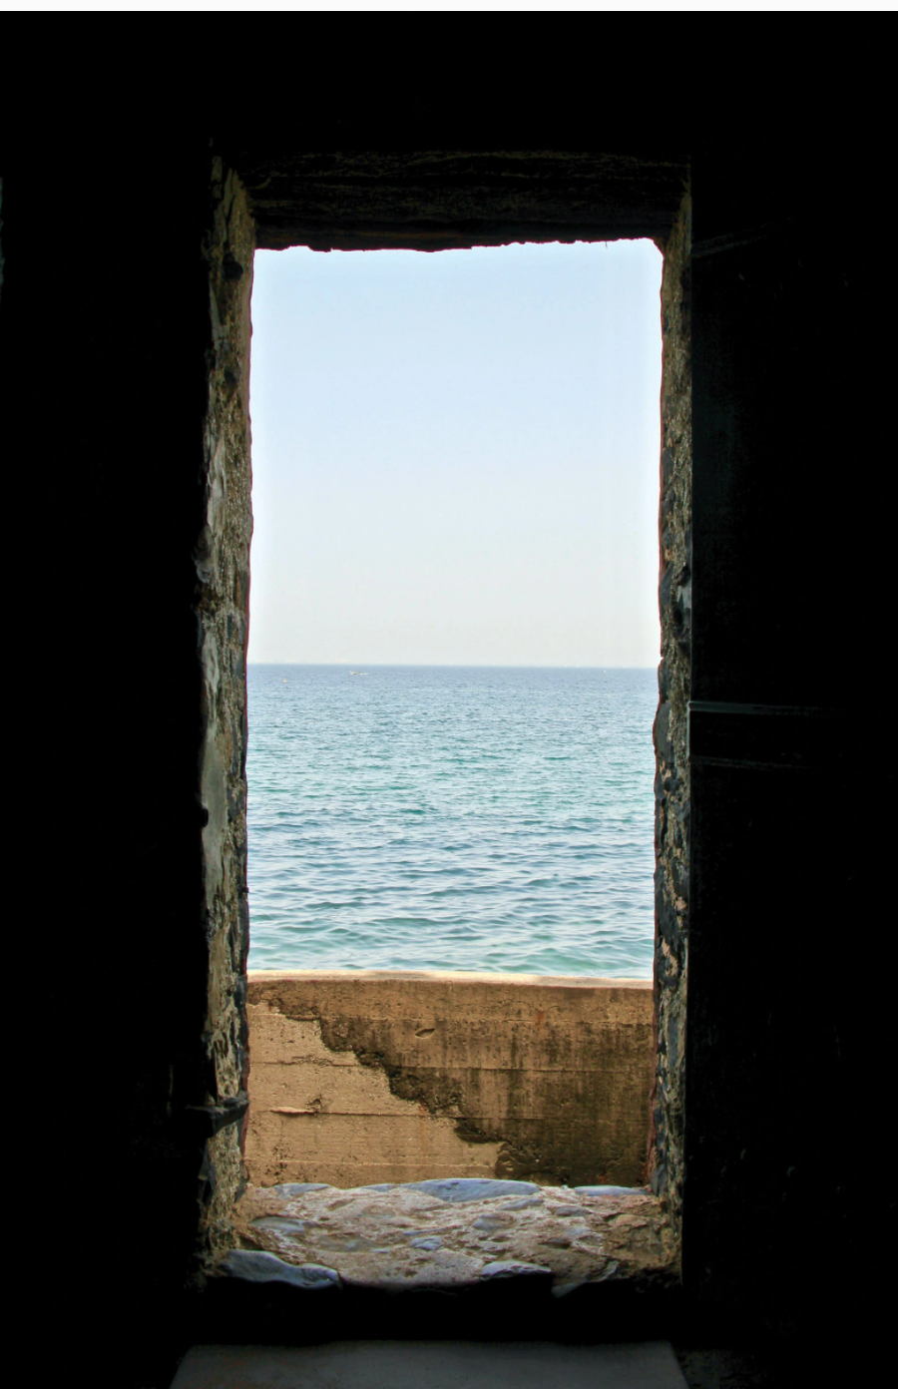

Keith Getter/Getty Images
The Door of No Return in the House of Slaves, which memorializes the slave trade, Gorée Island, Senegal, 2019
Smith also devotes a chapter to the continent that was pillaged by white enslavers. He and a Senegalese journalist tour Gorée Island, off Senegal, where they go to a structure known as the House of Slaves, which has a so-called Door of No Return that opens directly onto the sea. The House of Slaves is a magnet for tourists because of Gorée Island’s reputation as the largest slave-trading post in Africa. Millions of enslaved people, it was once believed, walked through the Door of No Return and boarded ships that took them to the New World. But researchers have found that some 33,000 people, not millions, were transported from Gorée Island. The fabled door, as a tour guide at the House of Slaves explains, “probably never really led to ships”; more likely “that was the place where waste was thrown into the sea.” But, the guide says, “the slave house crystallizes all of the slave trade…. It’s a symbol of the slave trade.”
Strangely, Smith does not take what would seem to be the natural next step in his narrative: describing in detail the nightmare of the Middle Passage. Having used the House of Slaves as a synecdoche of that horror, he turns to the topic of cultural memory on Gorée Island. During his tour there, he learns that many street names in Senegal refer to European colonials, much like the Confederate references that haunted him in his home country.
In Africa, as in the US, this public honoring of past oppressors is now being questioned. Smith goes to a girls’ boarding school whose history teacher, Hasan Kane, explains that he wants to help his students “to understand the heinous implications of slavery without letting them fall into a state of paralysis.” Hasan’s approach evidently has had an uncertain impact. Smith interviews several of his students, one of whom says that slavery should be forgotten because it might produce lasting feelings of inferiority among Africans; another insists that the terrible outcome of white colonization must be remembered, because it helps to explain her current society. As for the House of Slaves, the girls agree: “It makes us sad. A point of sadness in our hearts.”
Smith ends his book on a deeply personal note: “My grandfather’s grandfather was enslaved.” He records conversations with his eighty-nine-year-old grandfather, who has awful memories of lynching during Jim Crow, and his seventy-nine-year-old grandmother, whose life, he writes, “like my grandfather’s, was enveloped by the fog of segregation.” His grandmother remembers that as a child, banned from public transportation because of her skin color, she walked to school along a dirt road in north Florida and was often struck by objects thrown at her from passing school buses filled with white children who screamed, “Go home, nigger! You ain’t got no business here!”
Smith’s style brims with poetic images. Some of his metaphors seem forced, as when he describes the vowels of a song that “stretched out and hung like the laundry on a warm day.” But most of his images work well, such as these: “The cool air tiptoed across my skin”; the slave quarters at Whitney Plantation were “a muted green that faded halfway down the wood, like the residue of tears that never reached the bottom of its face.” Smith’s book, though tendentious in its treatment of Lincoln and the Declaration of Independence, is informative, emotionally intense, and stylistically adventurous—a fresh lesson in how the word can be passed down.

David S. Reynolds
David S. Reynolds, a Distinguished Professor at the CUNY Graduate Center, is the author or editor of sixteen books, including, most recently, Abe: Abraham Lincoln in His Times.

